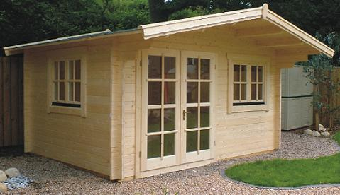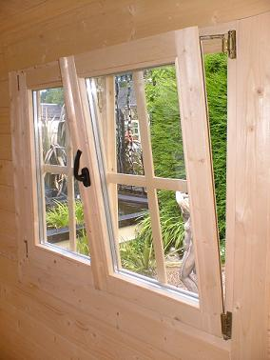
Tornio Roof projection: Front 1.00 m
Back 0.20 m
Side 0.30 m

Walls: 45 mm double tongue and groove logs
Floor: 20 mm tongue and groove floor boards on an impregnated base frame
Roof: 20 mm tongue and groove roof boards supported on the 5 roof beams
Door: Double-glazed doors
Windows: Double-glazed tilt ‘n‘ turn units

Tornio benefits: Completely sealed double glazed units
Coated aluminium sill for windows to prevent rot
Draft proof sealing round doors and windows
High quality window and door furnishings
Double action door lock

Possible Extras: 1m Terrace and hand rail extending full width of Cabin
0% APR
AVAILABLE,CONTACT
US FOR
DETAILS

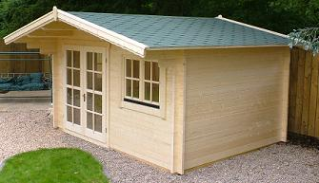

Size (m) |  | Door | Windows |  | Cabin Kit Only | Cabin Kit with Shingles | 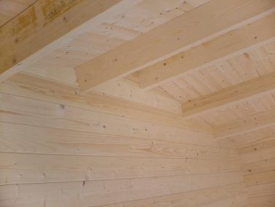  Extras
Width | Depth | Door | Front | Side | Cabin Kit Only | Cabin Kit with Shingles | Build Cost | Terrace
3 | 3 | 1 ½, 135/196 | Single, 80/94 | Double, 120/94 | £2,319 | £2,469 | £300 | £138
4 | 3 | Double, 170/196 | Double, 120/94 | Double, 120/94 | £2,488 | £2,678 | £350 | £170
4 | 4 | Double, 170/196 | Double, 120/94 | Double, 120/94 | £2,505 | £2,745 | £400 | £170
4 | 5 | Double, 170/196 | Double, 120/94 | Double, 120/94 | £3,197 | £3,497 | £500 | £170
5 | 5 | Double, 170/196 | Double, 120/94 | Double, 120/94 | £3,571 | £3,946 | £600 | £218

